

| **Title: User interface design using UI tools for mini project** |
| --- |

**______________________________________________________________________**

**Aim:** To enable the students learn different user interface design tools and their aspects

**______________________________________________________________________**

**CO:** Prepare the System Design and Model **______________________________________________________________________**

**Books/ Journals/ Websites referred:**

1. Roger Pressman, “Software Engineering”, sixth edition, Tata McGraw Hill.

**__________________________________________________________________**

**Pre Lab/ Prior Concepts:**

The user interface Need:

System users often judge a system by its interface rather than its functionality. A poorly designed interface can cause a user to make catastrophic errors. Poor user interface design is the reason why so many software systems are never used. Most users of business systems interact with these systems through graphical interfaces although.

GUI characteristics

Windows Multiple windows allow different information to be displayed simultaneously on the user’s screen. Icons different types of information. On some systems, icons represent files; on others, icons represent processes. Menus Commands are selected from a menu rather than typed in a command language. A pointing device such as a mouse is used for selecting choices from a menu or indicating items of interest in a window.

GUI advantages

They are easy to learn and use.

• Users without experience can learn to use the system quickly

The user may switch quickly from one task to another and can interact with several different applications.

Information remains visible in its own window when attention is switched.

Fast, full-screen interaction is possible with immediate access to anywhere on the

**User Interface Design Models**

User model — a profile of all end users of the system

Design model — a design realization of the user model

Mental model (system perception) — the user’s mental image of what the interface is

Implementation model — the interface “look and feel” coupled with supporting information that describe interface syntax and semantics

**User interface design analysis:**

The overall process for analysing and designing a user interface begins with the creation of different models of system function (as perceived from the outside). You begin by delineating the human- and computer-oriented tasks that are required to achieve system function and then considering the design issues that apply to all interface designs. Tools are used to prototype and ultimately implement the design model, and the result is evaluated by end users for quality.

**Study and describe any one user interface tool.**

**Qt**, a powerful user interface (UI) toolkit widely used for developing cross-platform applications.

**Qt** is a comprehensive C++ framework that provides tools for creating graphical user interfaces (GUIs) and other applications. It allows developers to create applications that can run on various platforms such as Windows, macOS, Linux, Android, and iOS, without modifying the codebase significantly. Qt offers a wide range of widgets (buttons, text fields, dialogs, etc.) and supports both traditional desktop and modern mobile UIs.

Key features include:

* **Cross-Platform Development:** Write code once and deploy it on multiple platforms.
* **Extensive Library of Widgets:** Provides pre-built UI components that are customizable.
* **Signal-Slot Mechanism:** A core feature that enables easy communication between UI elements and backend logic.
* **Qt Designer:** A drag-and-drop interface to design UIs visually.
* **Support for 2D and 3D Graphics:** Integrated tools for creating rich graphics applications.

Qt is popular for building both simple and complex UIs due to its versatility and efficiency.



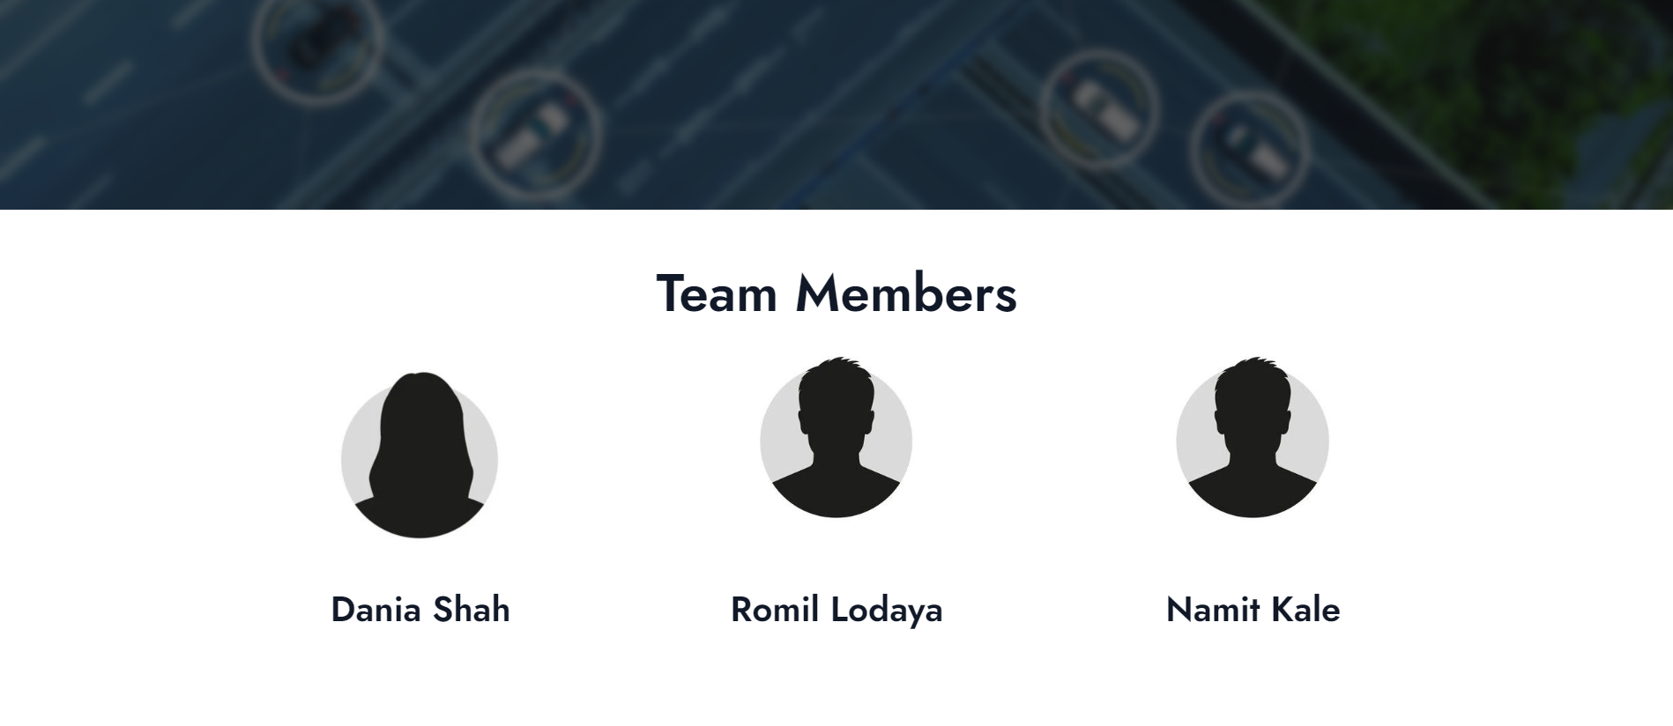

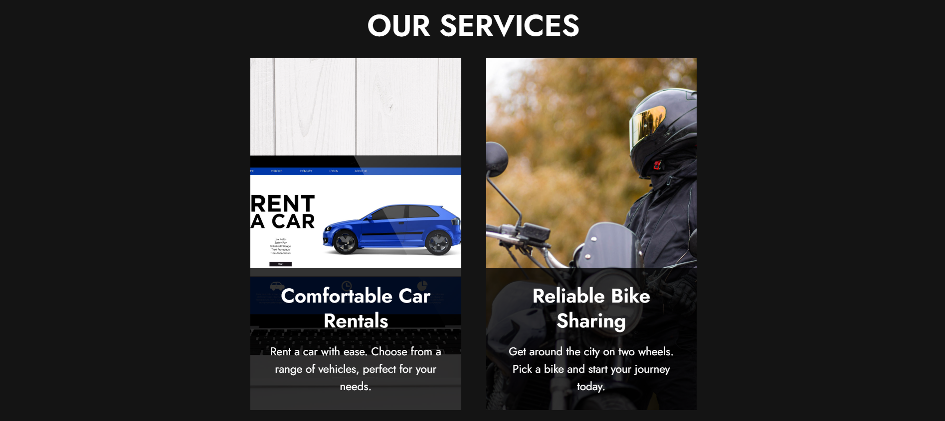



**CONCLUSION:**

This project helped effectively learn and apply various UI design tools, significantly improving my system design skills.

**Post Lab Descriptive Questions**

1. State various types of UI design tools.

* **Wireframing Tools**
  + Sketch
  + Balsamiq
  + Figma
* **Prototyping Tools**
  + Adobe XD
  + InVision
  + Axure RP
* **Graphic Design Tools**
  + Adobe Photoshop
  + Adobe Illustrator
  + Affinity Designer
* **User Flow and Mapping Tools**
  + FlowMapp
  + Whimsical
  + Lucidchart
* **Collaboration and Handoff Tools**
  + Zeplin
  + Abstract
  + Figma (also used for collaboration)
* **Animation and Interaction Design Tools**
  + Principle
  + Framer
  + After Effects
* **Icon Design Tools**
  + IcoMoon
  + Font Awesome
  + Noun Project

These tools cater to different stages of UI design, from conceptualization to final design and developer handoff.